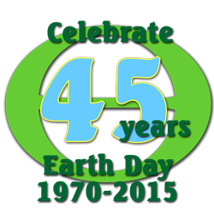
1) Over the period of at least a week, engage in any 5 smart environmental efforts of kindness (SEEK).
2) Choose 3 to 5 from this list and if you wish you can include two of your own ideas, for a total of 5.
3) For each act, include a picture as evidence and
4) Explain how it relates to concepts we learned in the course. An example is shown in the first of the chart. Minimum 75 words per row.

ACT | DATE(S) | PICTORIAL EVIDENCE | HOW IT RELATES TO COURSE CONCEPTS
Composting | April 5 - 28 | 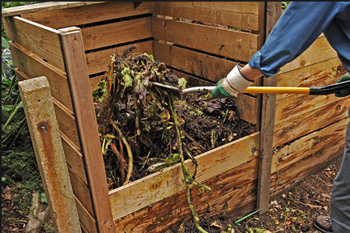 | - Composting reduces vegetable waste and eliminates the need to transport and handle such waste.  - No CO₂ is released from transportation, aiding climate change  - Some of the carbon gets tied up in humus and is not released as CO₂  - Ammonium and phosphates remain in the compost material and can be added to flowers and vegetables, reducing the need for industrial fertilizer.  - Compost holds the above ions and reduces runoff, thus helping eutrophication problem  - More growth of plant material removes carbon dioxide from the atmosphere  - Compost acts as a buffer, meaning it keeps the pH steady, which helps plants.
Get a teacher to avoid taking their car to work on Earth Day | April 22
Walk to school on Earth Day
Wear a green band on Earth Day and explain climate change to at least one student not in STE.
Remove plastic trash from the school yard and recycle it.
Protest after school in a peaceful manner in the parking lot in front of students or staff who drive to school on Earth Day.

