Chem Review: A Set of Offbeat and Easier Questions for 2013 (for solutions, see June exam center on web site)

- For each of the following reactions:
- Give the number of steps in each reaction. (each step has its own activation energy)
- Find the value of the highest activation energy.
- Out of the two or three steps that each reaction has, which is most likely to be the slowest?
- Is the overall reaction exothermic? What is the overall H?
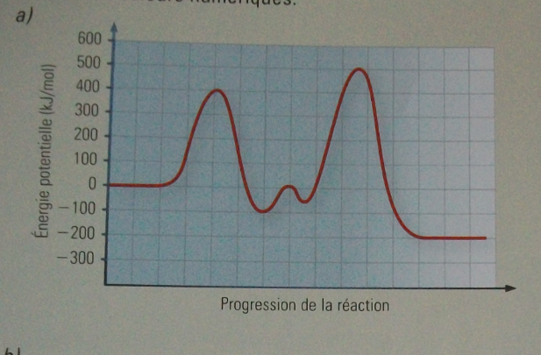
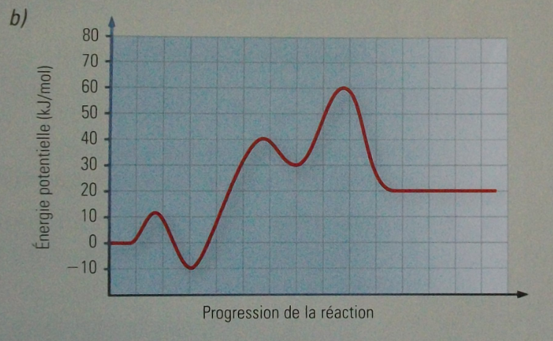
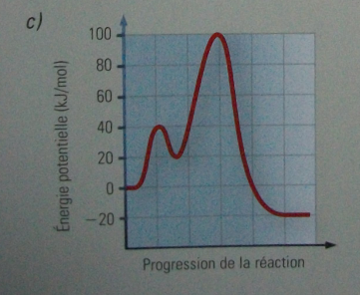

- The May 6th 2013 edition of the Economist ran an interesting story about the American chestnut which was almost wiped out in the 20th century. A fungus infecting Chinese chestnuts spread to indigenous trees, killing almost 2 billion of them.
The story goes on to report about how a combination of hybridization and genetic engineering may allow the American chestnut to make a comeback.

The fungus kills because it secretes oxalic acid.
Oxalic (1) | H₂C₂O₄ | Oxalate ion HC₂O₄⁻ | K_{A}= 5.9 x 10⁻²

- Write an equation and calculate the pH of a 1.0 M solution of H₂C₂O₄

- Biologists have isolated a gene from wheat which produces and enzyme than then converts oxalate to carbon dioxide.

Show a distribution of kinetic energies for the breakdown of oxalate with and without the enzyme.

- They have also incorporated the oxalate gene into a plasmid and have fooled the American chestnut into incorporating the gene into its own DNA.
What will the chestnut start doing? How will this help it survive the fungus?
- By the way, is the conversion of HC₂O₄^{- to CO}₂ an oxidation? Show why or why not.

- If another acid has a K_{A} of 5.1 X 10⁻³, how does its strength compare to that of oxalic acid?

- Why can’t pH be used to compare the relative strengths of two different acids?

- a) How many grams of Tl(OH)₃ will you find in 50.0 ml of a saturated solution? Its Ksp is a whoppingly-low 1.68 X 10 ⁻⁴⁴.

b) What effect will the addition of acid have on the above equilibrium?

